Chinese Ceramic Art Council, USA International Academy of Ceramics
1518 S. De Anza Blvd. San Jose, CA 95129, USA Musée Ariana
Tel. 800-689-2529, Fax 1-408-343-0117, 10 avenue de la Paix
Email: ChineseClayArt@hotmail.com, CH-1202 Geneva, Switzerland
Website: www.ChineseClayArt.com Website: www.aic-iac.org

January 4th, 2016,
Letter of Invitation

Professor Zhang Jingjing,
Vice-Director of International Exchange, Jingdezhen Ceramic Institute
Jingdezhen City, Jiangxi Province, P.R. CHINA 333403, Tel: 86-15079839166

Dear Professor Zhang Jingjing:

On the behalf of Chinese Ceramic Art Council USA, I would like to invite from the group of educators from Jingdezhen Ceramic Institute to participate the 50th annual conference of ceramic arts on education at Kansas City, Missouri in March 16th to 19th 2016.

Founded in 1998, Chinese Ceramic Art Council USA is a California based organization that promotes exchanges between East and West in ceramic art communities. It is our annual program for organizing a Chinese delegation to participate in the Annual Conference of the National Council on Education for Ceramic Art (NCECA) www.NCECA.net. This event represents the largest and most significant events dedicated to ceramic art and education in the US and around world.

The itinerary is: March 15, departure from China to Kansas City, Missouri for the conference until March 18, and they will leave for home flights on March 19, and arrived in Shanghai on March 20th. They will pay all of the traveling costs by themselves. Please find the name list as following:

Name | Gender | DOB | Position | Institution
Feng Hao | Male | April 13th, 1970 | Director of Academic Affairs Office | Jingdezhen Ceramic Institute
Chen Liping | Female | August 10th, 1971 | Dean of Graduate School | Jingdezhen Ceramic Institute
Huang Sheng | Male | March 23rd, 1969 | Deputy Dean of School of Ceramic and Fine Arts | Jingdezhen Ceramic Institute
Liu JianMin | Male | September 21st,1967 | Deputy Director of National Engineering Research Center for Domestic and Building Ceramics | Jingdezhen Ceramic Institute
Zhang JingJing | Female | April 19th, 1975 | Deputy Director of International Affairs Office | Jingdezhen Ceramic Institute

For further questions please contact us at: 800-689-(CLAY) 2529. Thank you very much!

Sincerely,

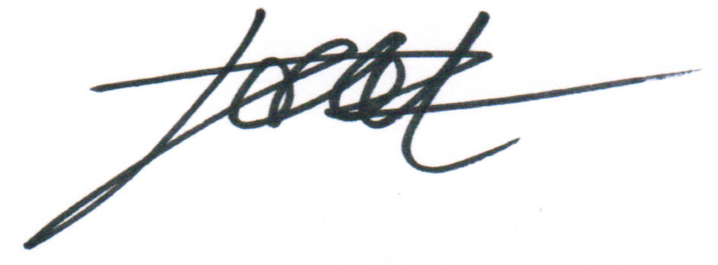
Guangzhen “Po” Zhou, IAC council member, representative for China,
Director, Chinese Ceramic Art Council, USA International Academy of Ceramics

